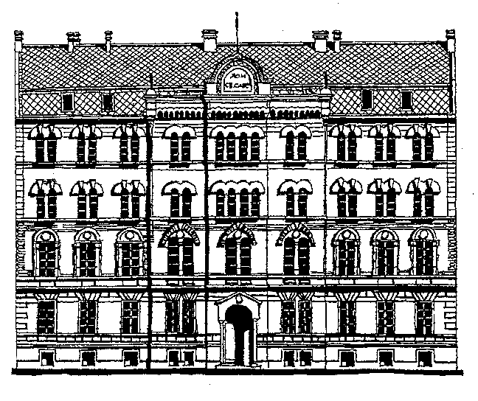 | DOCTORAL STUDIES
PROPOSAL OF DOCTORAL THESIS TO  COLLEGIUM DOCTORAL STUDIES |  |  | School year  20___/20___
Student data
Name  Surname  index number |  | Scientific field of study
Data on doctoral dissertation mentor
Name  Surname |  | Scientific field  Title  Institution
Proposal topic for doctoral thesis
Title

With the application of the doctoral thesis to Collegium doctoral studies necessary is to enclose the following documents:

- Seminar (up to 10 pages)
- Short professional biography written in the third person singular
- Photocopy of PhD index

Date | Mentor signature  Student signature

Opinion of Collegium of doctoral studies
After elaboration of the doctoral thesis Collegium doctoral studies:

accepted topic

not accepted topic

Date

Vice Dean of Science Faculty of Physics

